**The UDP Bandmap**

Aki Yoshida JA1NLX

## 9.0 RPTR (WSJT/JTDX UDP message repeater)

For those who want eye candy programs to monitor UDP messages, but can't get them to work because Logger32 is using port 2237, then right click RPTR at the right of the lower status bar.  Click Setup WSJT/JTDX UDP repeater. Check Enable SEND A, set the port number to 2238, and click APPLY.

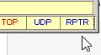

UBM_14H

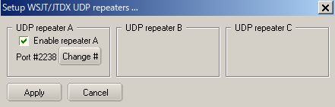

UBM_14I

If you want to use GridTracker (by N0TLL) then follow the steps below:

Run GridTracker and click Setup icon. The default Port for Receive UDP Message is 2237.

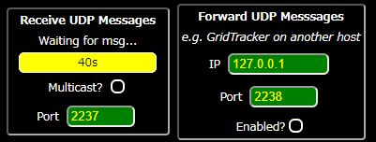

UBM_14I1

Type 2238 for the port of Receive UDP Message and 2239 for the port of Forward UDP Message.These changes are saved in GridTracker.

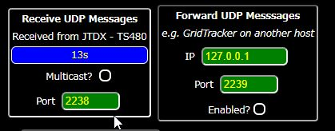

UBM_14J

If you want to use default UDP port 2237 in GridTracker then you can change UDP port in Logger32 and WSJT-X/JTDX.

In the case of Logger32:

(a) right click RPTR at the right of the lower status bar.  Click Setup WSJT/JTDX UDP repeater. Check Enable SEND A, set the port number to 2237, and click APPLY.

(b) right click on UDP in the lower status bar, click Change WSJT/JTDX port #, type 2238 and click OK. You must change UDP port to 2238 as well in WSJT-X/JTDX.

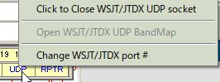

UBM_14K

If you want to use UDPdecoder (by JA1NLX) then follow the steps below. UDPdecoder receives UDP message from JTDX/WSJT-X via RPTR and display UDP message, DT distribution graph, S/N process graph for specific callsign and lowest S/N.

Run Logger32.

Run JTDX/WSJT-X

Open RPTR (see UBM_14H and UBM_14I)

Run UDPdecoder. Set UDP port # (Default is 2238)

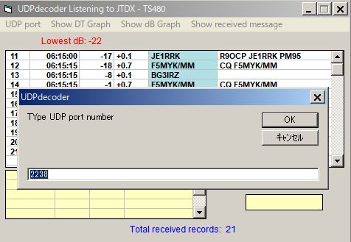

UBM_14L

**10.0 Sending DX Spot**

If you do not automatically send DX Spots for all FT4/FT8 QSOs, you will see a menu item SPOT appear when a QSO is automatically logged. Click the menu to send a preformatted DX Spot. If you choose not to make a DX Spot, then the preformatted text remains available to send the DX Spot until it is overwritten by for the next QSO that is automatically logged.

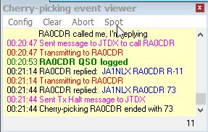

UBM_14M

UBM=14N

UBM_14N

## 11.0 ~~10.0~~. TIPS

If you have "Show only callsigns calling CQ" and "Show only highlighted callsigns" checked then the only station that are highlighted and calling CQ will show.

The BLOCK COUNTRY and BLOCK CONTINENT options look for a Country/Continent match with the Logger32 Current Operator.  If you have the Logger32 operator set to "At the Beach" or "Club Station" or something other than the callsign of where you are operation, the results will be unpredictable.

Try to change settings of "DX Spot highlight colors" in DX Spot Window and settings of "Setup phone/digital modes" in Tools menu. It affects the way to display highlight colors and tooltips in UDP Bandmap.